HR
In HR it includes three modules
- Recruitment:Recruitment is considered as the first step of the actions of the human resources management system.In Odoo, you can find a separate module to manage all recruitment procedures inside a company. Using this platform you can identify vacant job positions in your organization, post job openings, invite applicants, and manage the hiring process.
- Employees:Employees module helps you to coordinate every employee and an overview of each employee from every department in the organization can be retrieved easily. Even the employee contracts can be easily handled using the Employee module of Odoo.
- Payroll:Odoo Payroll allows you to define every aspect of your company's payroll process so calculations can be run automatically each pay period. Reminders ensure you never miss a pay period and a confirmation step allows you to confirm payroll before running.

Recruitment

To create job position

Recruitment -> Configuration -> Job positions -> Create

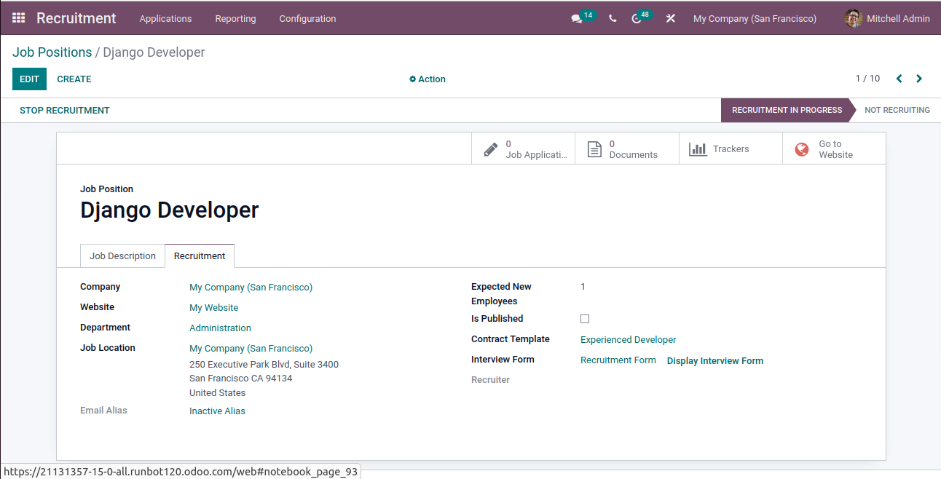
after creating job position the next step is hiring

To apply for job

Recruitment -> Job Position -> click what position you want (django developer) -> Apply Now -->

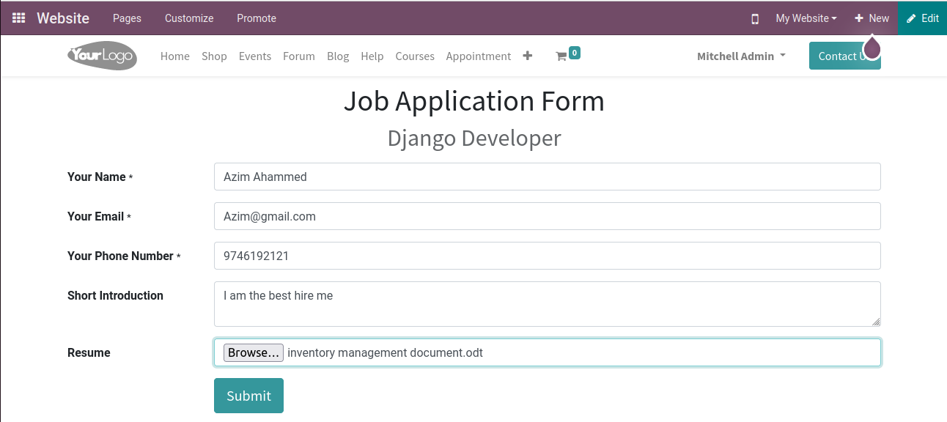
after filling this form click on submit and then you will go through interview if you hired you get an offer letter

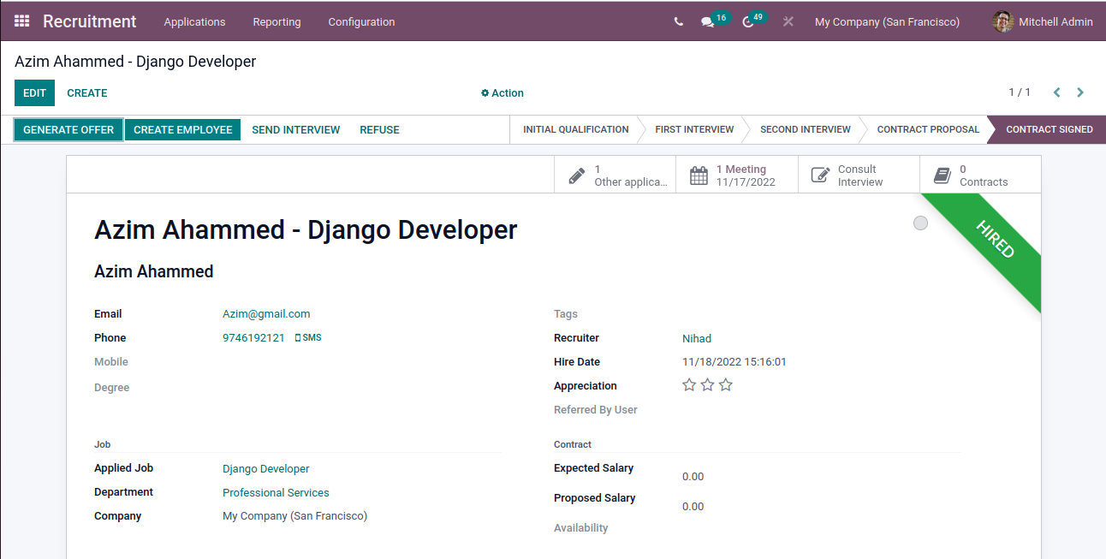
from here you can directily create an employee
click on the create employee

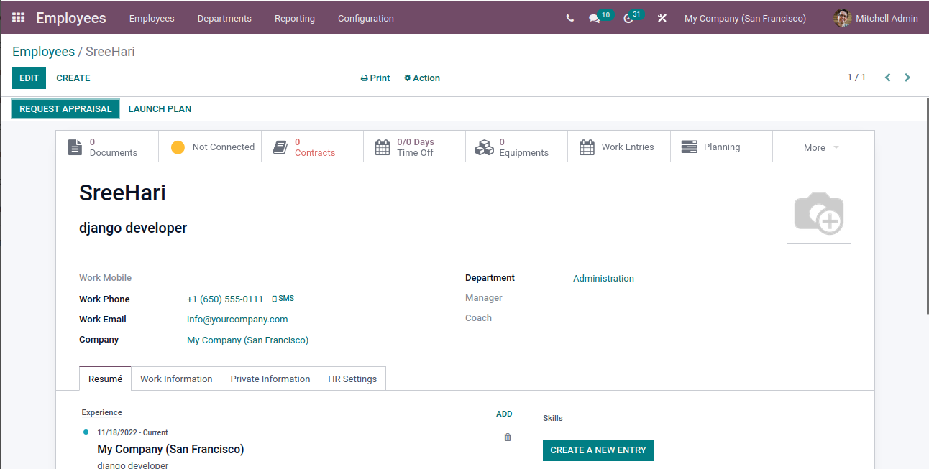
Or you can create directily from the employee module

To create employees
Employees -> Employee -> Create ->

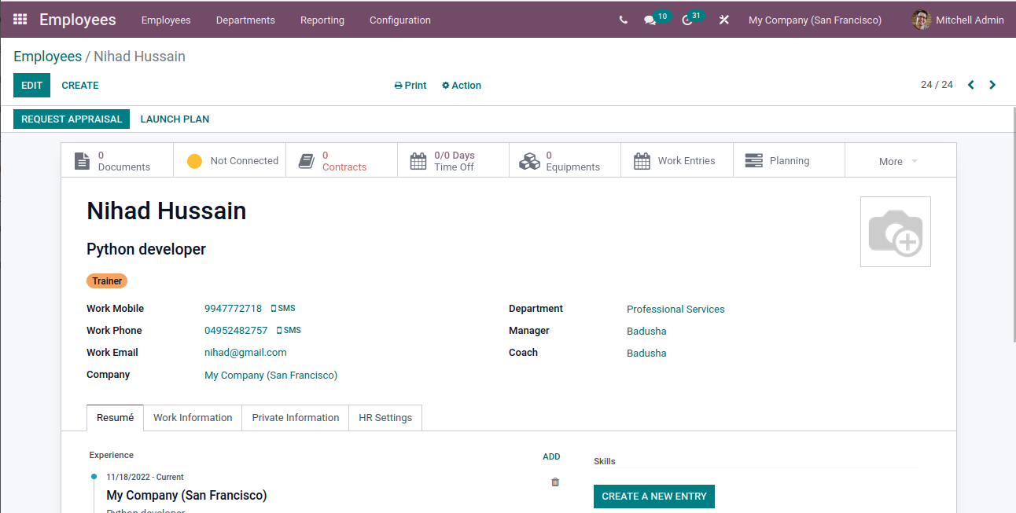
Contracts
- In this module, you will be able to find all the details about the employee, contracts, salary information, and the status of each contract. The contract can also be created by selecting the employee.
Employees Module -> Employees -> All Contracts
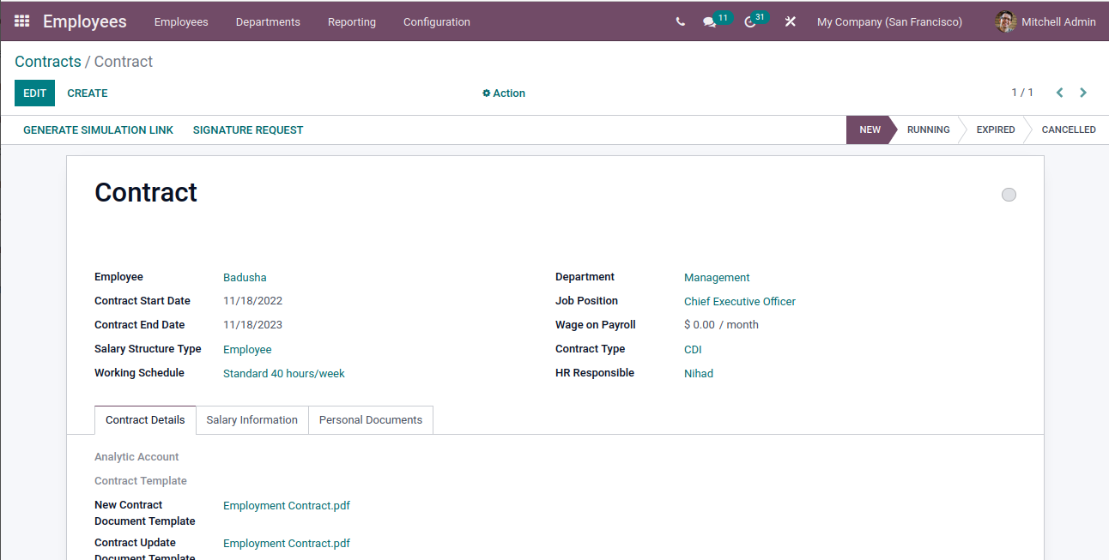
payroll
- Odoo Payroll module makes it easy to organize all payroll activities in a company
- Payrolls are the entire amount of wages that a firm pays to its employees
- The Payslip options include To pay, All Payslips, and Batches. To understand how payslips work in the odoo environments

Payslips to pay

To create To pay
Payroll -> Payships -> To Pay -> Create
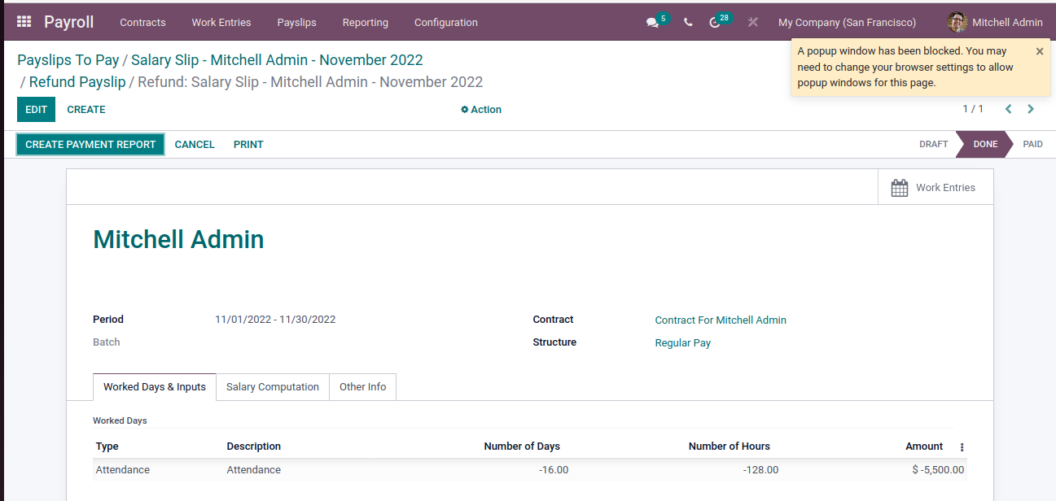
Contract
- The Employee Contract can be defined as a signed document between the employee and the employer.
- It is very important to define the working hours, payment details, duties, and responsibilities of the employee before joining the work
- Using the Contract menu, you can easily create contracts for the employees along with the details of work, job position, contract terms, duties, salary structure, contract validity, work permit, time schedule, and many more.
Batches
- The Payslip Batches menu is available under the Payslip tab of the Odoo Payroll module.
- This feature is an excellent support to you for generating a payslip for a batch of employees.
- The Odoo Payroll system allows you to create and manage batches.

To create Payslips Batches
Payroll → Payslips → Batches → Create →
